Assignment 2.2:

Task:3: Create a file max-temp.txt in local FS. Put some 10-15 records of date and temperature example: dd-mm-yyyy,temperature

Example:

10-01-1990,10

10-02-1991,20

Move this file to HDFS at /user/acadgild/hadoop.

First we created the file max-temp.txt in local file system, then added 10-15 records into the file. Later we moved file from local file system to hadoop file system using –put command.

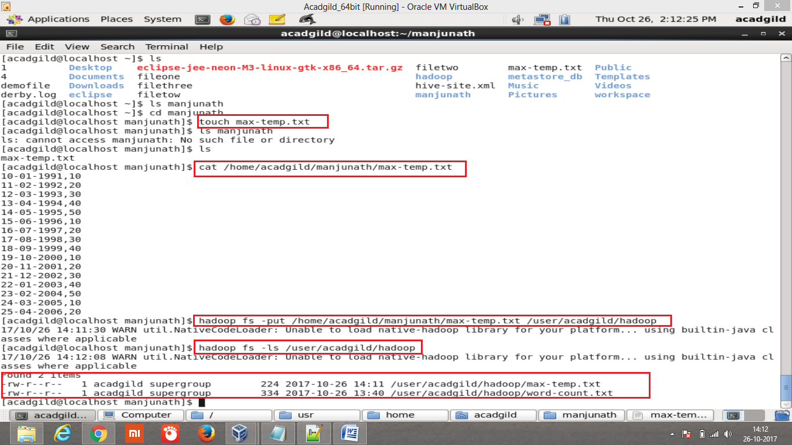

Tasks: 4: Change the permission of the file /user/acadgild/hadoop/max-temp.txt, such that

only the owner and the group members have full control over the file. Others do not have any control over it.

For the file max-temp.txt we have highlighted the initial access permission. Then we changed the control over the file using the command –chmode.

